**Fall 2015: COMP 7300 Advanced Computer Architecture**

**Test 2 (100 pts)**

Grading policy:

¼ Credit for correct answer only

¾ Credit for well written and solid justification/facts/arguments. **Show your work.**

**For Test 2, we assume a CPU with a 32-bit address bus.**

1. **Cache**
2. **(8 points)** We consider a 2-way associative 32 KB cache with 4 KB blocks. The CPU generates the address 0x204865.
   1. **(3 points)** What is the block address (in Hexa **OR** binary) of Block ***B*** containing address 0x204865?
   2. **(3 points)** What is Block B’s tag (in Hexa **OR** binary)?
   3. **(2 points)** What is the index where Block ***B*** willbe stored in the cache?
3. **(12 points)** Consider the cache on the figure below. Answer the following questions based on the figure below

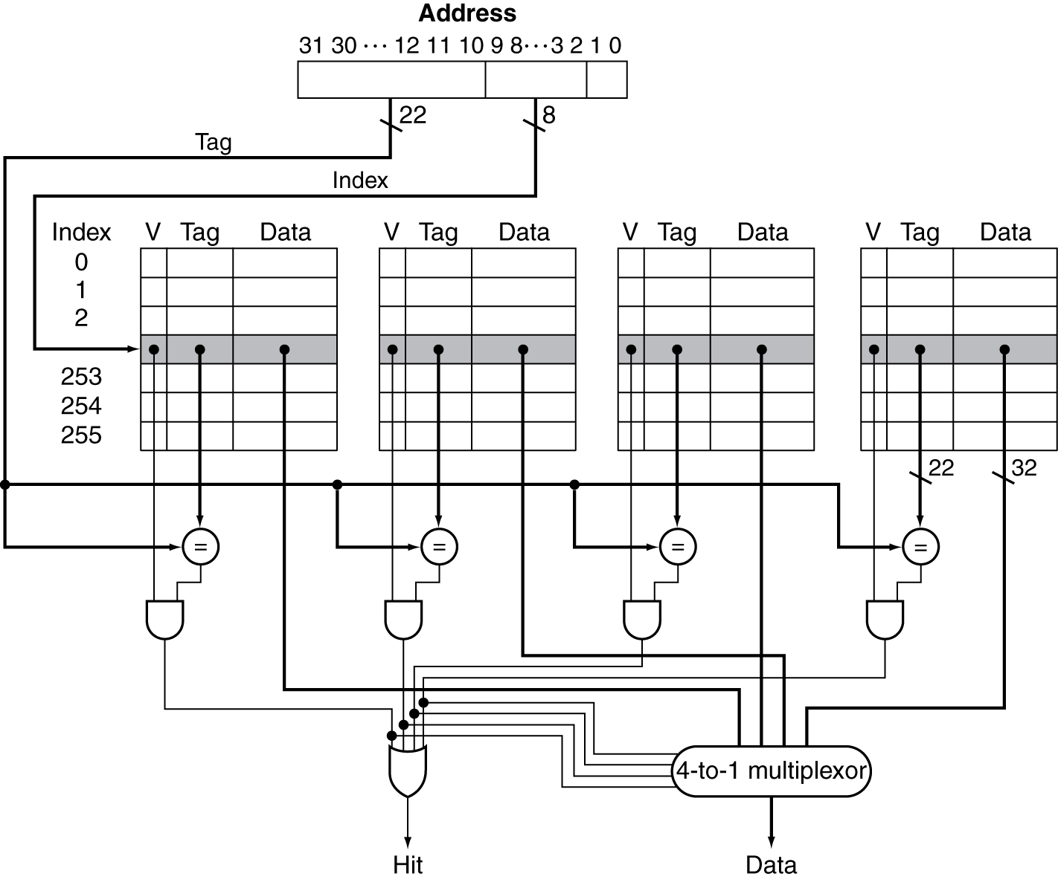

**Figure 1**

* 1. **(2 points)** Is the above cache 2-way associative cache? Explain why
  2. **(10 points) Redraw** Figure 1 (above) such that the cache becomes 2-way associative with a block size of 64 bytes and a cache size of 64 KB of data. Just like for Figure 1, **indicate clearly the size** of the busses as well as the smallest and largest Indexes.

**Exercise 1: (30 points)** We assume that the data cache size is 2 KB (data) and the block size is 32 bytes. We assume that M[i][j] is adjacent to M[i][j+1] in the memory and that the cache is fully associative using LRU replacing. Consider the following code:

**char** A[64][64];

int i,j;

for (j = 0; j < 32; j++){

for (i = 0; i < 64; i++)

A[i][j] = A[i][j] ^ A[i][n-1-j];

A[i][n-1-j] = A[i][j] ^ A[i][n-1-j];

A[i][j] = A[i][j] ^ A[i][n-1-j];

}

This code performs a SPECIAL column-wise transpose. As indicated on **Figure 2**, the transposition is performed as follows: the first column(j=0) and the last column (j=63) are swapped, the second column (j=1) and the column (j = 62) are swapped, and so on…

**Figure 2**

We assume that the code is in a separate instruction cache and the variables i and j are in registers.

1. **(2 points)** How many blocks are needed to store one line of the matrix?
2. **(2 points)** How many blocks are needed to store the full matrix?
3. **(2 points)** How many blocks does the cache contain?
4. **(6 points)** How many compulsory misses occur?
5. **(4 points)** How many capacity misses occur?
6. **(2 points)** How many conflict misses occur?
7. **(6 points)** Would a loop interchange decrease the number of capacity misses? If yes, rewrite the loops with the loop interchange (**no need** to repeat the swapping instructions) and provide the new number of capacity misses.
8. **(2 points)** What would be the number of compulsory misses with a loop interchange?
9. **(4 points)** What should be the minimal size of the cache if we wanted to use blocking?
10. **Virtual Memory (15 points)**

We consider a 32-bit address bus and a 2 MB physical memory. Page size is 32 KB. Assuming a validity bit and a dirty bit, the objective is to compute the size of the table.

1. **(2 points)** How many entries does the page table have?
2. **(2 points)** How many frames are in the main memory?
3. **(4 points)** What is the size of each entry (page table)?
4. **(3 points)** What is then the size of the page table?
5. **(4 points)** Suppose that physical memory is managed like direct-mapped cache: each page with number i is stored in the frame with number n % 26. What is in hexadecimal the physical address corresponding to the virtual (logical address) 0x567489?

**Exercise 2) (20 points)**

Consider the datapath on this figure:

FullDataPath

1. **(2 points)** Consider the following instruction:

***subw*** $r1, Constant($r2) $r1 <- Constant - $r2 (Constant is 16 bits wide)

**Example**: if $r2 = 8 and Constant = 120, the CPU will compute the difference (120 - 8) and will store it in Register $r1, i.e $r1 = 112 after the execution of the instruction.

**Propose** an instruction format for ***subw*** (consistent with the instruction set defined so far. This means that the first 6 most significant bits are reserved for the opcode).

|  |  |
| --- | --- |
| Opcode |  |

1. **(1 point)** Does the full datapath support the *subw* instruction? **Answer only Yes or No**. (**No justification is needed here**). If the answer is Yes, jump to Question 4.
2. **(2 points)** If the answer to Question 2) is **NO**, add **on the figure** all **needed** lines, units, resources, inputs, outputs, multiplexers…. to support the instruction *subw*.
3. **(6 points)** Based on the instruction code you proposed, **draw/highlight on the figure** the datapath used by the instruction *subw*.
4. **(8 points)** After you draw the datapath, label the relevant buses with size and the content for the instruction ***subw*** *$3, 250($23)*. Assume that $3 = 32, $23 = 48.
5. **(1 point)** Provide the final values of the registers $3 and $25.

**Exercise 3**: **(15 points)** Deriving the pipeline speed up

Consider a monocycle CPU with 4 operations (stages) that take, 200ps, 200ps, 200ps, and 400ps.

1. **(1 point)** What is the latency of one instruction on the monocycle CPU?
2. **(1 point)** Consider a program P with n instructions. What is the execution time for Program P (expression as a function of n) on the monocycle CPU?
3. **(11 points)** We want to pipeline the CPU above with one stage per operation. We neglect the buffer time between stages. All the questions below apply to the pipeline .
   1. **(3 points)** What should be the clock frequency for the pipelined CPU?
   2. **(3 points)** What is the latency for one instruction for the pipelined CPU?
   3. **(2 point)** What is the throughput (bandwidth) in MIPS of the pipelined CPU?
   4. **(3 points)** Consider a program P with n instruction. What is the execution time for Program P? (Make sure to take into account the phase to fill up the pipeline and wind it up)

4) **(2 points)** What is the expression of the speed up (monocycle versus pipelined)? If n tends to infinity, what is the speed up?